Task 2: Build Your Student Digital Portfolio

- LinkedIn:
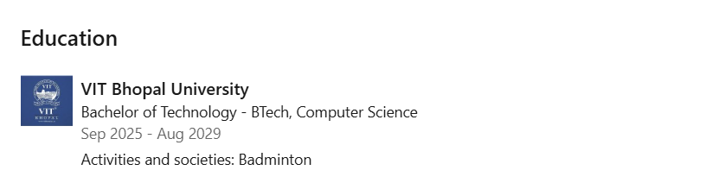
It is a digital platform where we can post profile and get updated in areas of our interests. We make network and connection with people who has same interests as ours. By frequently updating our profile, makes professionals understand that you are into job search, internships or simply connections.
I am planning to post my certificates, achievements so that companies can approach me on the bases of my skills, experience and consistency which the key to success .After each year of B.tech I will increase my connections that I am interested in like entrepreneurship, startups.

2.Research Gate:
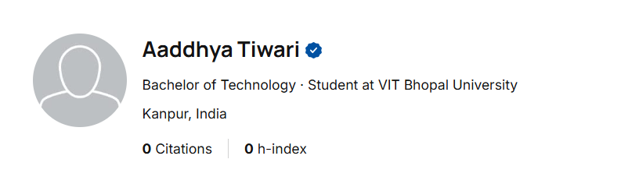
Is a networking platform between student and professor, scientists and researcher to share research papers. It increases academic networking and connects to professionals resulting in career development.

I am interested in research work and discovering new fields and concepts. So I next four years I will try to make network with research professionals, building my communication skills so that I confidently present my research papers. This will help me in my PhD.

3.Stack overflow:
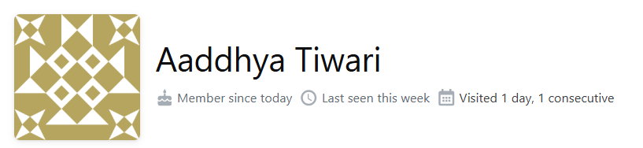

Is a collaborative Q&A platform for programmers where user ask questions, write answers, vote on best solutions. Asking genuine and smart questions increases knowledge, writing skills and vocabulary. It is a powerful tool for programmers where my engaging in challenges we can boost coding skills.
I plan to ask doubts relating to coding , AI and computer science, consider and appreciate solutions that resolve my doubt. Be consistent in appearing in challenges and improving my coding skills.

